Extracting Date Components

Definition
# Source: AI Source: Provided by: [Data Path: Persons Table -> ID Column: 1, Name_En Column: Motasem Essam] -> From: [ChatGPT] on [12/10/2025]
Extracting Date Components is a date/time transformation technique where a date value is separated into its individual parts, such as year, month, and day, to make the data easier to analyze and use in machine learning models.

Key Idea
# Source: AI Source: Provided by: [Data Path: Persons Table -> ID Column: 1, Name_En Column: Motasem Essam] -> From: [ChatGPT] on [12/10/2025]
A full date contains several pieces of information. By splitting the date into separate components, analysts can identify patterns, trends, and seasonal effects more easily.

Common Date Components
# Source: AI Source: Provided by: [Data Path: Persons Table -> ID Column: 1, Name_En Column: Motasem Essam] -> From: [ChatGPT] on [12/10/2025]
The most commonly extracted parts from a date include:
- Year – useful for identifying long-term trends
- Month – helps detect seasonal patterns
- Day – identifies specific daily activity patterns
Other useful components may include:
- Day of Week (Monday–Sunday)
- Week of Year
- Quarter of Year

Example
# Source: AI Source: Provided by: [Data Path: Persons Table -> ID Column: 1, Name_En Column: Motasem Essam] -> From: [ChatGPT] on [12/10/2025]
Original dataset:

Order ID | Order Date
1 | 2024-05-18
2 | 2024-06-10
3 | 2024-07-22
After extracting components:
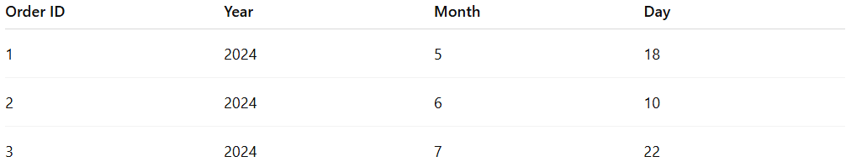
Order ID | Year | Month | Day
1 | 2024 | 5 | 18
2 | 2024 | 6 | 10
3 | 2024 | 7 | 22

Example with Additional Components
# Source: AI Source: Provided by: [Data Path: Persons Table -> ID Column: 1, Name_En Column: Motasem Essam] -> From: [ChatGPT] on [12/10/2025]
Original value:
Date
2024-05-18
After transformation:
Year | Month | Day | Day of Week
2024 | 5 | 18 | Saturday

Advantages
# Source: AI Source: Provided by: [Data Path: Persons Table -> ID Column: 1, Name_En Column: Motasem Essam] -> From: [ChatGPT] on [12/10/2025]
- Helps identify seasonal trends and time patterns
- Improves machine learning model performance
- Makes date data more structured and interpretable

Disadvantages
# Source: AI Source: Provided by: [Data Path: Persons Table -> ID Column: 1, Name_En Column: Motasem Essam] -> From: [ChatGPT] on [12/10/2025]
- Increases the number of features in the dataset
- Some temporal relationships may require additional feature engineering

